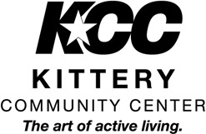
2023 Summer Camp Program Automatic Tuition Withdrawal Form

Choose Credit Card Payment or Electronic Check (do not need to fill out both)

Child’s Name
Parent’s Name (Name On Card)
Credit/Debit Card Number
Expiration Date CVV Number (3 digit code on back)
Electronic Check Account Number
Electronic Check Routing Number

By signing this form, I authorize the Kittery Community Center to charge the above account number for Summer Camp tuition payment. Please choose from the following options:
Pay my summer camp tuition in full today!
Pay my deposit of (must be at least 25% of total fee) and pay oﬀ the rest of my balance on June 2nd.
Pay my deposit of (must be at least 25% of total fee) and pay oﬀ the rest of my balance on the following dates (must be paid by June 2nd):
Payment 1 - $ on __________
Payment 2 - $ on __________
Payment 3 - $ on __________

Parent’s Signature:

Date:

